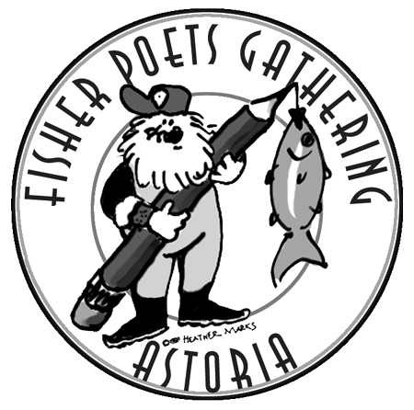 Thanksgiving 2014

Fisherpoets!

The FisherPoets Gathering tide has switched and is starting to flood hard. We’d best start paying attention around here. We expect another big high.

This one will be our 18th FisherPoets Gathering. Children who were conceived during the first are veteran hands and young skippers now themselves. Friends we knew then have crossed the bar. Meanwhile we relish a chance to gather again in February with you to celebrate commercial fishing and the work we love mostly. We hope you’ll join us.

If you’ve earned a living in the commercial fishing community, you’re invited. The 2015 FisherPoets Gathering program starts Friday evening February 27 and winds up Sunday March 1 about noon but, if you can make it to town by Thursday, join us that evening for our annual pre-function, no-host dinner and open mic at Clemente’s restaurant.

If you haven’t been on the schedule before it’s important you send us a sample of your stuff. Keep our commercial fishing work in mind and don’t stray far from our roots. If you’ve been strictly a prose writer, well, have a go at a poem anyway. You’ll never find a more empathetic audience.

If you know people who may not write but who, with some encouragement, can tell a good story, let us know. We’ll consider asking them to participate in Saturday's Story Circle.

If you’ve an idea for Saturday’s workshops you’d like to present or see presented, let us know. We’ll pursue it.

Bring your chapbooks, cards, artwork, CDs and so forth. You can sell these, thanks to our volunteers, at no cost as always, at our FisherPoets Gathering bookstore. There will be copies there of “Anchored in Deep Water” the remarkable fisherpoets anthology painstakingly edited by Pat Dixon and delightfully illustrated by Chelsea Stephen. At “In the Tote” our on-line fisherpoet anthology www.inthetote.com you can have a look, and even order a copy.

The Astoria Riverwalk Inn (503.325.2013) at the west mooring basing is offering $60 rooms to fisherpoets and friends again this year. The Astoria-Warrenton Chamber of Commerce has plenty of other lodging information at www.travelastoria.com. If you have special needs or requests, give us a shout. We’ll see what we can do.

After we pay our bills, we’ll divvy up the gate and send participants a modest travel stipend, graduated in consideration of those who travel farthest.

We’re looking forward to a lot of blue smoke in the in-box in the next couple of weeks.
Let us know by January 10 if you’re coming so we can build a happy schedule in a timely fashion. We’ll keep a running list of confirmed participants at our FisherPoets Gathering website www.fisherpoets.org.

More from here for you who are coming after the New Year.

We’re looking forward to seeing you in Astoria pretty soon.
Best wishes to you and yours at Thanksgiving.

For the FisherPoets Planning Committee,

Jon Broderick
www.fisherpoets.org
broderick507@centurylink.net

